Topic - Environmental Sustainability: Waste Management

Introduction – We’re looking for a solution by creating a web-based application that will serve as a platform for consumers to get rid of accumulated plastic and other recyclable waste at home while also benefiting technologically.

Working – The prototype will function as follows:

* Identifying the bio-degradable wastes through **image screening** and making them reusable.
* Users generate revenue in the form of **cashback points** by selling these bio-degradable plastic wastes.
* Generation of equivalent amount of cashback points according to the quality and quantity of plastic wastes through **Machine Learning (ML) and Artificial Intelligence (AI**).
* The nearest trader to the **customer’s location** is assigned to collect the wastes through path optimization.
* People can also **purchase recycled products** and other items manufactured from reusable plastics both from our website at cheaper prices.
* Offers a basic set with **3 colorful bins** (Recycle, Compost, Landfill) with clear, concise labels.
* Can function in **multiple languages**.

Use Cases -

* Simply take a **snapshot** and send it to our platform if you have a certain amount of plastic waste at home.
* We can use **Al and ML** to assess the quality and quantity of plastic waste and **generate cashback points** based on that information.
* Through an automation system the model **tracks the user's location** and the nearest trader will be allocated to pick up the wastes.
* One can also **purchase recycled plastic items** from the same platform.

Technology Stack –

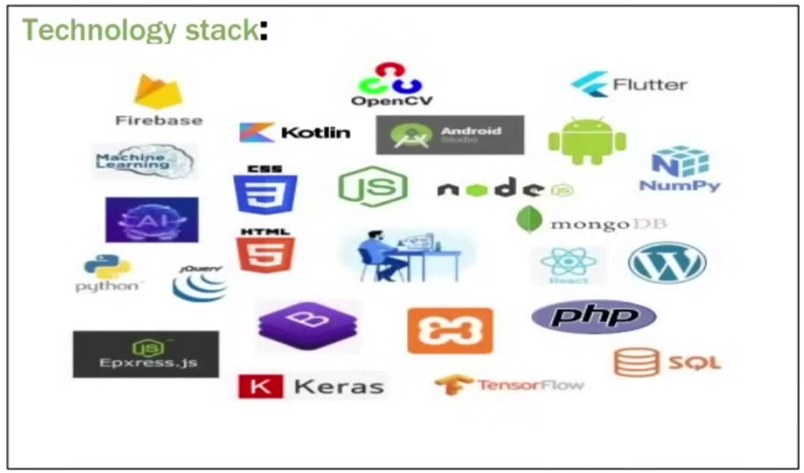

﻿

﻿

Show Stoppers –

* A **multilingual** android and **web-based platform**, based on **32 different languages**, which serves the term "**Waste Managemen**t" - a proper and efficient structure
* Providing a **secure employment** to those vendors who had unstable sources of income and were collecting recyclables door-to-door.
* Automatic generation of cashback points according to the quality and quantity of plastic wastes through **Machine Learning and Artificial Intelligence.**
* By enabling an additional option to incorporate our platform at the end of their online bill, every e- commerce website will find it **easier to recycle the plastics** used in their product packaging.
* Users can donate a set amount towards the planting of a tree at the end of each purchase of **recycled plastic items**, the **geographical location** of which will be shared with the user later.